Hiyab Mengisteab
Data Engineering Capstone — D610

Part A: Project Summary
Summarize the real-data research question you identified in Task 1. Your summary should include justification for the research question you identified in Task 1, a description of the context in which the research question exists, and a discussion of your hypothesis.
- The research question for this study asks whether a linear regression (LR) model can be constructed on the X Restaurant dataset to accurately predict daily sales. This question is justified by the growing importance of data-driven forecasting in the restaurant industry, where accurate sales predictions can optimize inventory, staffing, and operational decisions. The study aims to explore how environmental and demographic factors—such as weather conditions, location, and population—affect restaurant sales performance. This project hypothesizes that a predictive MLR model can be developed from the available dataset with an accuracy exceeding 70%, thereby demonstrating the feasibility and business value of predictive modeling in restaurant sales forecasting.
Part B: Data Collection
Report on your data-collection process by describing the relevant data you collected, discussing one advantage and one disadvantage of the data-gathering methodology you used, and discussing how you overcame any challenges you encountered during the process of collecting your data.
- The data for this study were collected from two primary sources: a private business owner who provided the X Restaurant daily sales dataset and publicly available weather and demographic data obtained through the Meteostat API and city-level population statistics. The data include 8,830 daily records covering sales, location, and corresponding weather variables from January 2023 to June 2025. An advantage of this data-gathering method is that it combines real-world business data with reliable external environmental information, enabling a richer and more accurate predictive model. A disadvantage is that integrating multiple data sources introduced challenges with missing or misaligned records due to differences in date formats and station coverage. These issues were overcome through thorough data-cleaning and transformation processes, including standardizing dates, imputing missing values, and verifying data consistency across sources, ensuring a high-quality dataset for regression modeling.

Part C: Data Extraction and Preparation
Describe your data-extraction and -preparation process and provide screenshots to illustrate each step. Explain the tools and techniques you used for data extraction and data preparation, including how these tools and techniques were used on the data. Justify why you used these particular tools and techniques, including one advantage and one disadvantage of using them with your data-extraction and -preparation methods.
- I first obtained the daily sales data for the X Restaurant, which included sales amounts by city and date. Next, I extracted additional data on daily weather conditions and estimated population using the Meteostat API and publicly available demographic sources. These datasets were imported and processed using Python and the pandas library for cleaning, formatting, and data transformation. After ensuring that all date fields were standardized, I joined the datasets on the time column to create a single integrated dataset combining sales, weather, and population variables. Python and pandas were chosen because they provide powerful, efficient tools for handling large datasets and performing data manipulation in an automated, reproducible way. An advantage of using pandas is its flexibility in cleaning and merging diverse data sources; however, a disadvantage is that it requires sufficient programming knowledge and careful data validation to avoid alignment or formatting errors.
- 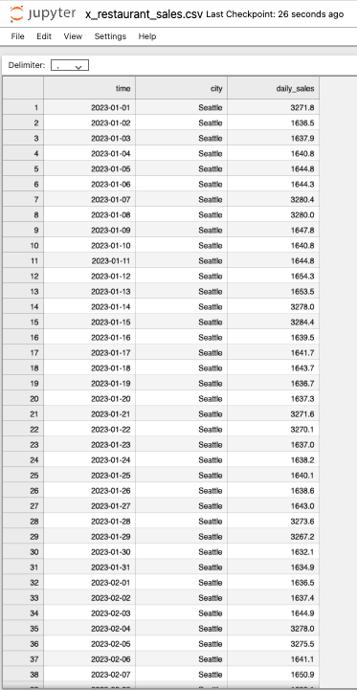
- 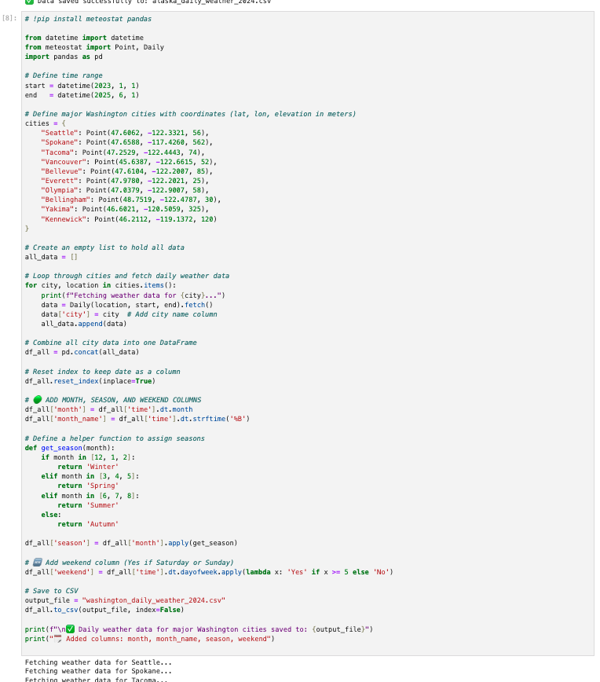
- 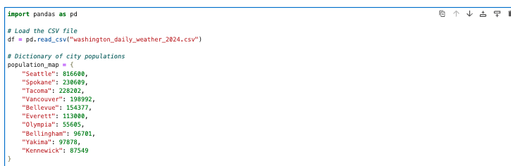
- 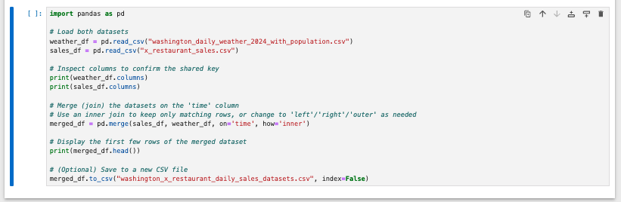

Part D: Analysis
Report on your data-analysis process by describing the analysis techniques you used to appropriately analyze the data. Include the calculations you performed and their outputs. Justify how you selected the analysis techniques you used, including one advantage and one disadvantage of these techniques.
- The data-analysis process began with data transformation to prepare the dataset for modeling, including standardizing numerical variables and encoding categorical variables. I used Seaborn and Matplotlib to create scatterplots and visualizations to examine the relationships between the dependent variable (daily_sales) and independent variables such as weather, season, and city. The city column was transformed using one-hot encoding, while the season column was label-encoded to convert categorical variables into numeric formats suitable for modeling. I also reviewed PCA variance ratios to understand the variance captured by different components and assess dimensionality reduction opportunities.
- For predictive modeling, I applied Linear Regression using scikit-learn, and then refined the model using stepwise elimination and backward elimination techniques to select the most significant predictors. The resulting model was further evaluated with statsmodels, which provided coefficients, R-squared, and adjusted R-squared values to assess model fit. Finally, I calculated the Mean Squared Error (MSE) on both training and test data to quantify prediction accuracy.
- These techniques were selected because they effectively combine exploratory visualization, dimensionality assessment, feature selection, and regression modeling to create a robust predictive model. An advantage of this approach is that it allows both interpretability (through statsmodels coefficients and R²) and predictive performance assessment. A disadvantage is that stepwise and backward elimination can be computationally intensive and may sometimes exclude variables that have subtle but meaningful effects in combination with others.
- 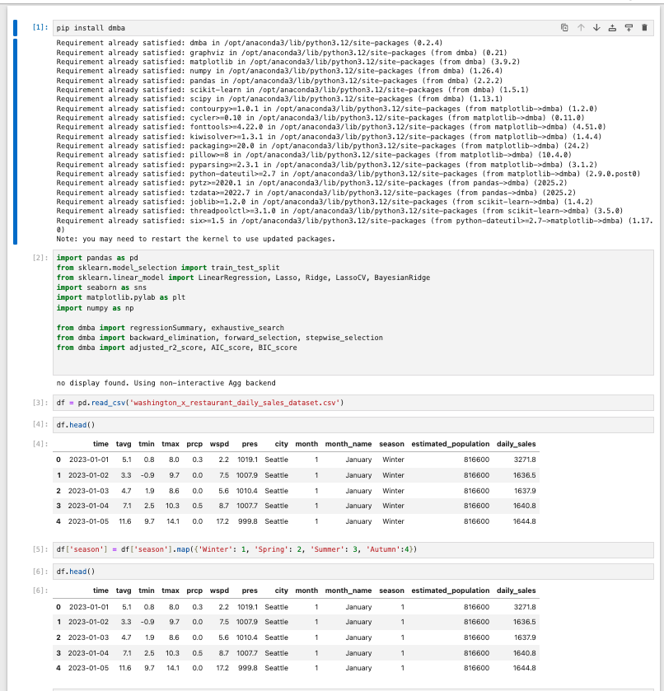
- 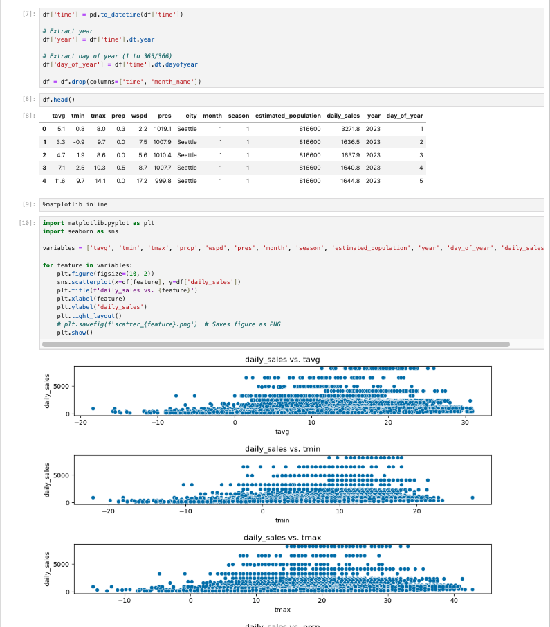
- 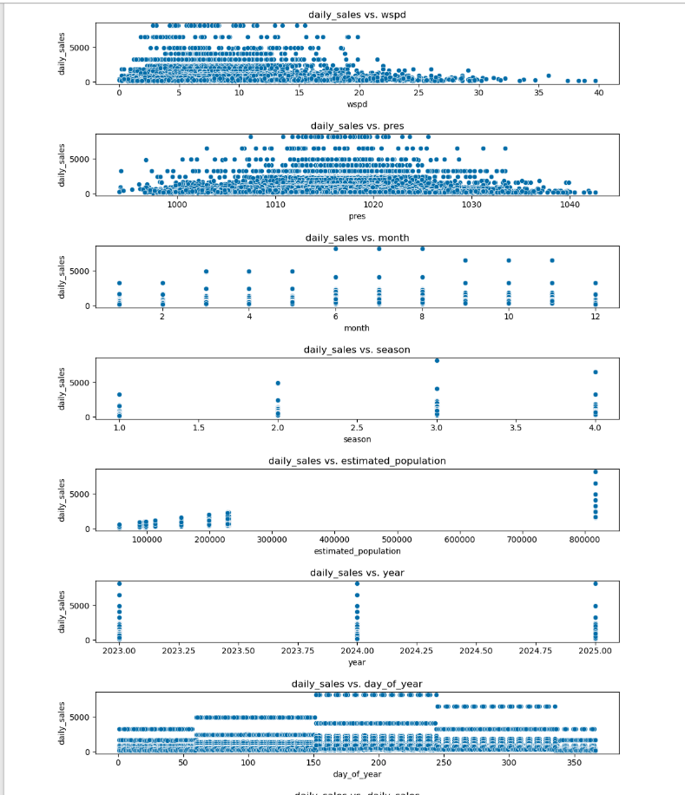
- 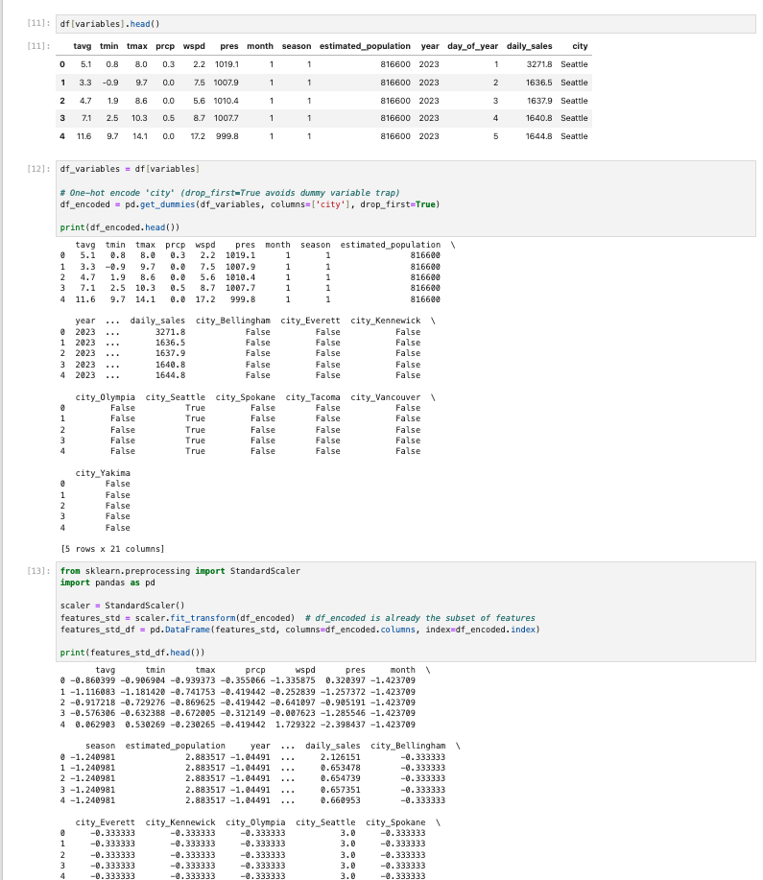
- 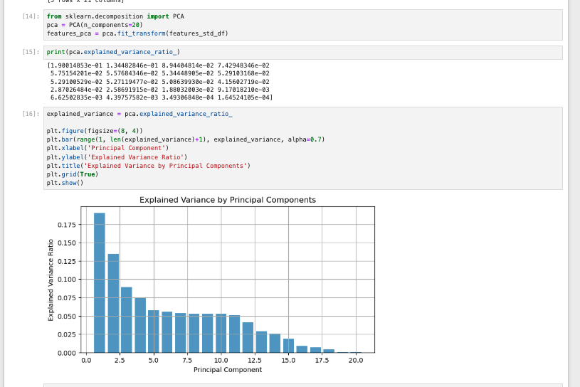
- 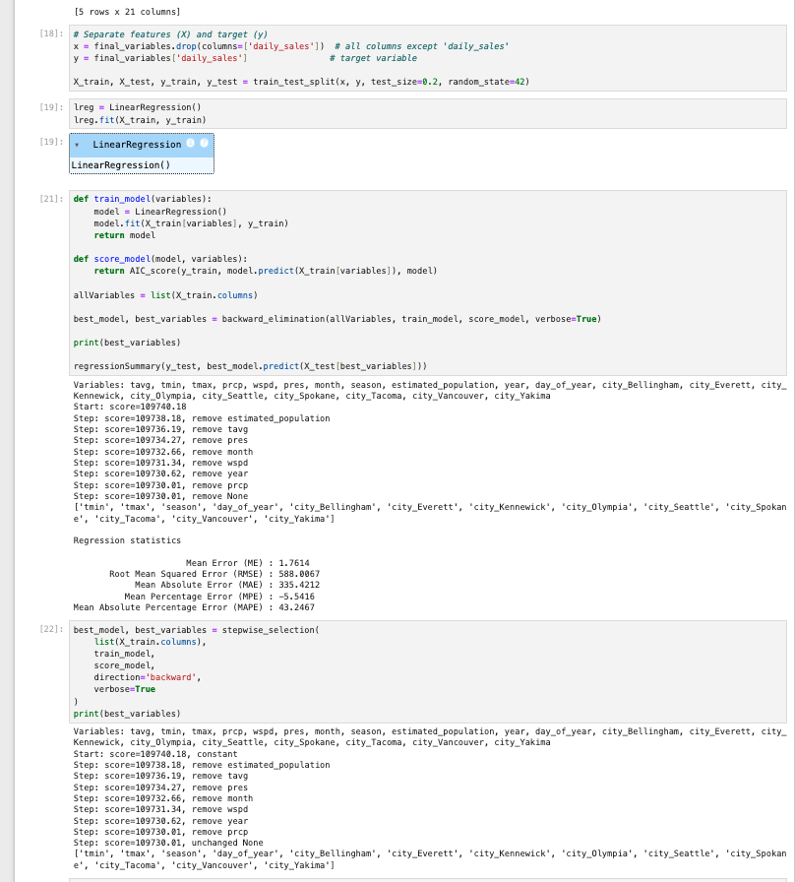
- 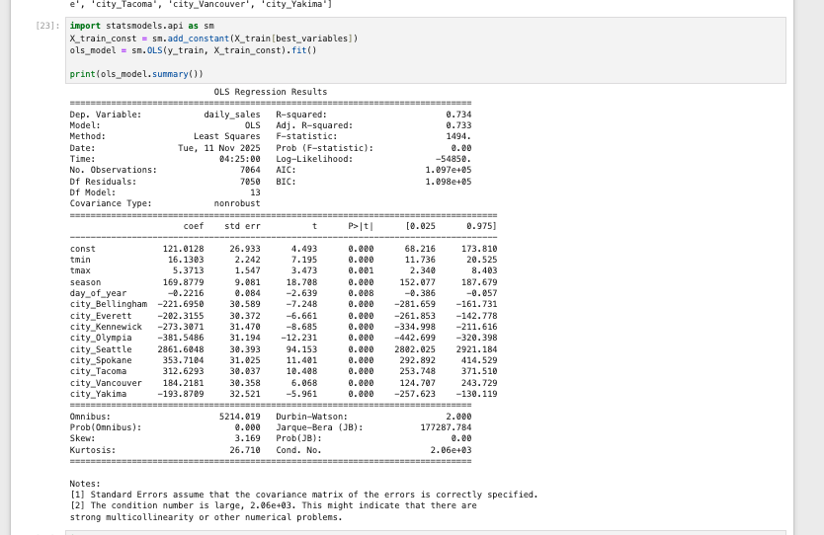
- 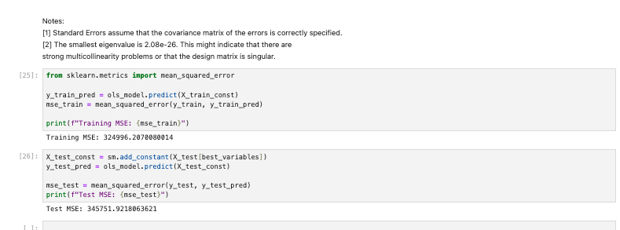

Part E: Outcomes and Implications
Summarize the implications of your data analysis by discussing the results in the context of the research question, including one limitation of your analysis. Within the context of your research question, recommend a course of action based on your results. Then propose two directions or approaches for future study of the dataset.
- The data analysis indicates that a multiple linear regression model can effectively predict daily restaurant sales, as evidenced by an R-squared of 0.734 and an adjusted R-squared of 0.733, meaning the model explains approximately 73% of the variance in daily sales. Key predictors such as minimum and maximum temperature, season, day of year, and city location are statistically significant (p < 0.01), highlighting that both environmental and geographic factors strongly influence sales. For instance, Seattle shows substantially higher sales compared to other cities, while cities like Olympia and Kennewick have negative coefficients relative to the baseline, suggesting location-specific demand differences.
- Based on the finding with backward elimination, the following variables showed the most impactful for the linear equation
Variable | Coefficient
Intercept | 121.0128
tmin | 16.1303
tmax | 5.3713
season | 169.8779
day_of_year | -0.2216
city_Bellingham | -221.6950
city_Everett | -202.3155
city_Kennewick | -273.3071
city_Olympia | -381.5486
city_Seattle | 2861.6048
city_Spokane | 353.7104
city_Tacoma | 312.6293
city_Vancouver | 184.2181
city_Yakima | -193.8709

- Mean Squared Error (MSE) measures the average of the squares of the errors—that is, the average squared difference between the actual and predicted values. The Test MSE is slightly more than the Training MSE. This is an encouraging sign because it shows that the model is not overfitting—it generalizes well to new data. The similarity in values suggests that the model performs consistently on both the training and test sets.
  - Training MSE: 324996.20
  - Test MSE: 345751.92
- The estimated multiple linear regression equation based on the provided coefficients is:
  - daily_sales =121.0128 +(16.1303⋅tmin) + (5.3713⋅tmax) + (169.8779⋅season) − (0.2216⋅day_of_year) − (221.6950⋅city_Bellingham) − (202.3155⋅city_Everett) − (273.3071⋅city_Kennewick) − (381.5486⋅city_Olympia) + (2861.6048⋅city_Seattle) + (353.7104⋅city_Spokane) + (312.6293⋅city_Tacoma) + (184.2181⋅city_Vancouver) − (193.8709⋅city_Yakima)
- One limitation of this analysis is that the model assumes linear relationships between predictors and sales; non-linear effects or interactions may exist that are not captured. Based on the results, the restaurant could prioritize staffing and inventory planning for high-demand cities and seasons, and adjust strategies according to predicted sales patterns influenced by temperature and seasonal trends.
- For future study, one approach could be to incorporate promotional, holiday, and event-based variables to improve prediction accuracy, and a second approach could involve testing non-linear or machine-learning models (e.g., random forest or gradient boosting) to capture complex interactions and potentially enhance predictive performance.

Reference:
- External resources not used in this submission

